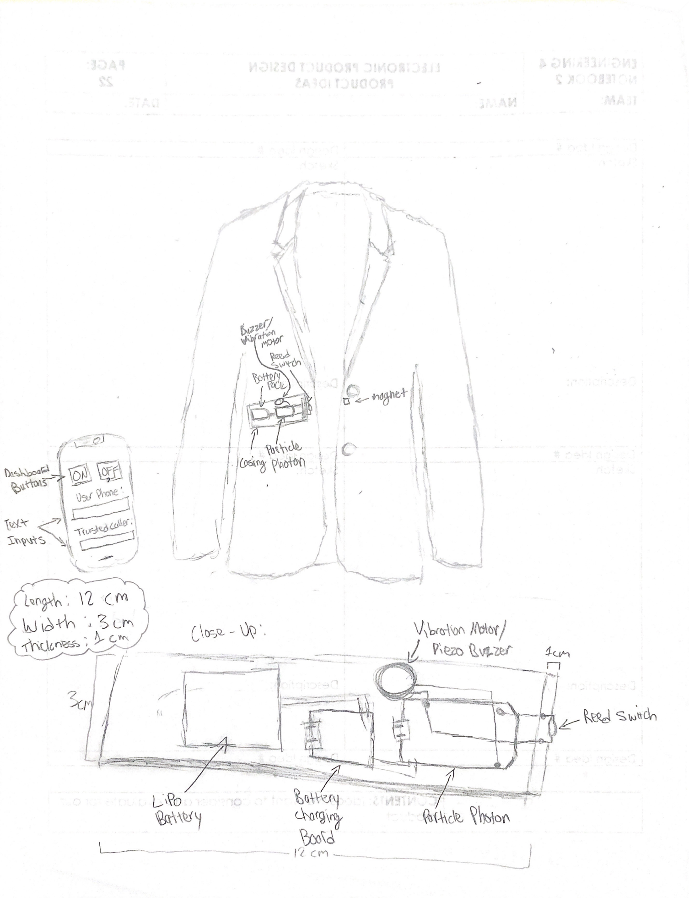

Device Name:

The “Heads Up” Button-Up

Household Item:

Button-up clothing item (Sweaters, jackets, coats, etc.)

Inputs Used:

Reed Switch & Dashboard Buttons

Outputs Used:

Calls/Text to friends and family & Vibration Motor or Piezo Element

How the Internet is Used:

The Internet is used to make calls and texts to multiple phones, and the Dashboard buttons use the internet to activate/deactivate the device. You can also use the Dashboard to set what numbers the device texts/calls.

How the whole device works:

If you are walking on the streets alone at night and end up in a dangerous situation (i.e. a stalker following you, a thief trying to rob you, an attempted kidnap, etc.), you can button the top button of your button-up to connect the magnet to the reed switch, which are sewn into opposite sides near where the top button is.

When the magnet is connected to the reed switch, it triggers Twilio to either a) make an automated call to the police with your own phone number as the caller ID or b) texts your friends and family and alerts them to your location using the Google Geocoding node. The text or call will also tell them to text the Twilio number if they are on their way, which will cause the vibration motor in the device to vibrate against your chest, letting you know that help is coming. This provides a discreet way of calling for help without alerting your attacker/stalker.

You can use buttons on the Dashboard to activate or deactivate the device when you want to button your clothing normally. There are also text inputs on the dashboard to set what numbers the device will text. All of the electronics will be stored inside of a thin compact case (about the size of a wallet) with the reed switch exposed at one end, so that the process of sewing into or onto an article of clothing is easier.

Our Projected Feasibility Ratings for the Device (1-5 scale):

___4__ Technical Feasibility

___5__ Fiscal Feasibility

___4__ Economic Feasibility

___5__ Political Feasibility ___3­__ Environmental Feasibility